**Inventory Turnover Analysis - Manufacturing Sector**

GOKULNATH K & E24755

**Overview**

Inventory turnover analysis in the manufacturing sector measures how efficiently a company uses its inventory to meet demand. It tracks how often stock is sold and replaced over a period, helping identify overstock or understock issues. High turnover indicates efficient inventory management, while low turnover suggests potential issues like excess stock or slow-moving products. Data analysts use this analysis to optimize inventory levels, reduce holding costs, and improve cash flow.

**Objective**

1. **Optimize Inventory Levels:** Maintain the right balance between supply and demand to prevent overstock or stockouts.
2. **Improve Cash Flow:** Increase turnover to reduce capital tied up in inventory, enhancing cash availability.
3. **Identify Inefficiencies:** Detect slow-moving or obsolete products, leading to improved production planning and efficiency.
4. **Reduce Holding Costs:** Minimize costs associated with storing and managing excess inventory.
5. **Enhance Forecasting:** Support more accurate demand forecasting for better inventory replenishment strategies.

**Assigned Task(s)**

* Inventory Turnover Analysis - Manufacturing Sector

**Task Details**

* **Task 31 :** Inventory turnover analysis in the manufacturing sector evaluates how efficiently inventory is sold and replaced over time. It helps data analysts optimize stock levels, reduce costs, and improve cash flow.
* **Status:** Completed.
* **Details:**

1. Analyzed Dataset : A larger dataset of 100 items was analyzed, with fields for Category, Sales, Beginning_Inventory, Ending_Inventory, and COGS.
2. Inventory Calculations: Calculated the average inventory, inventory turnover ratio (COGS / Average Inventory), and days to turnover (365 / Inventory Turnover).
3. Data Aggregation: Grouped data by product category to calculate the average inventory turnover per category.
4. Visualization: Created a bar chart using Seaborn to visualize the average inventory turnover by product category.
5. Random Data Generation: Used NumPy to randomly generate sales, inventory, and cost data for different product categories, creating a diverse dataset.

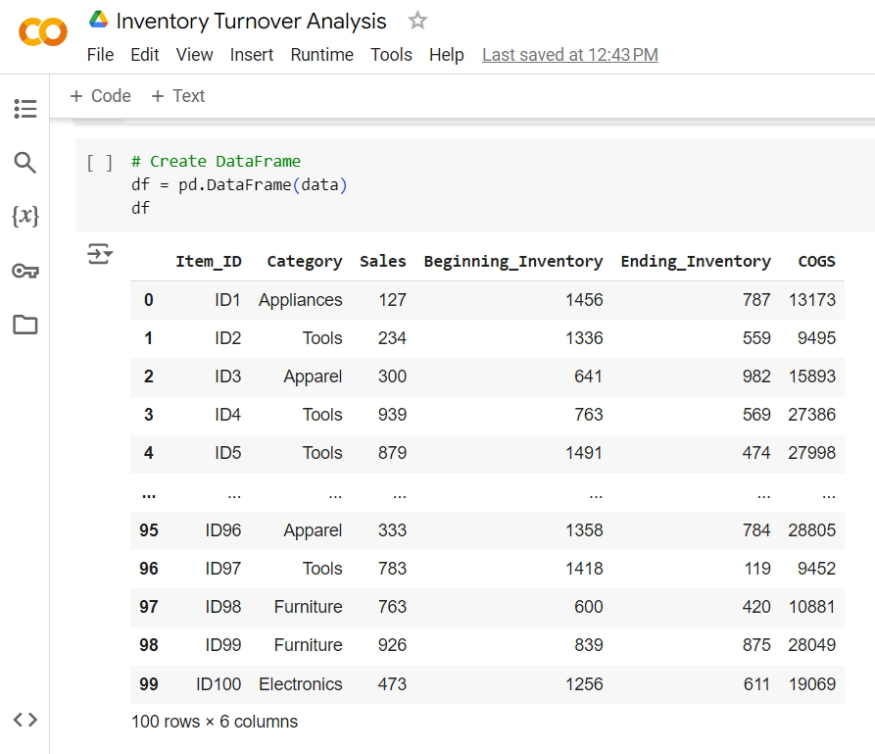

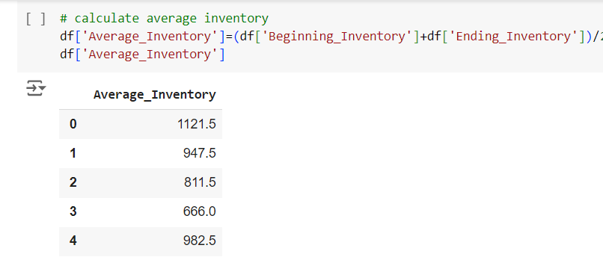

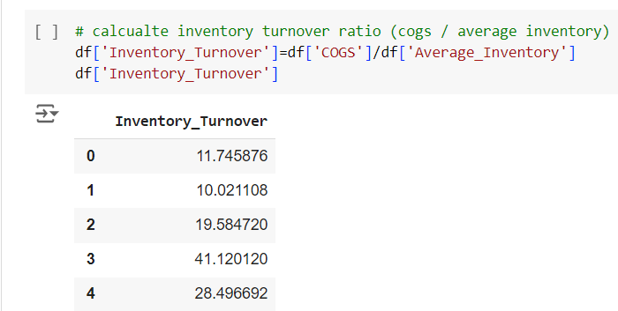

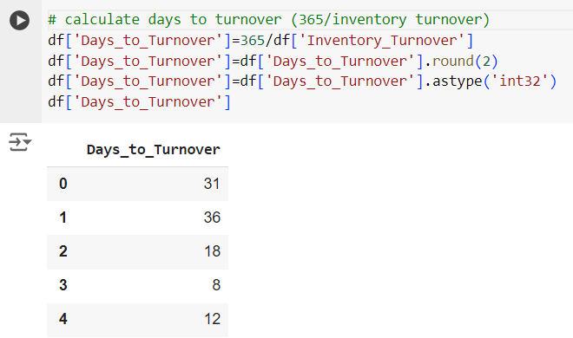

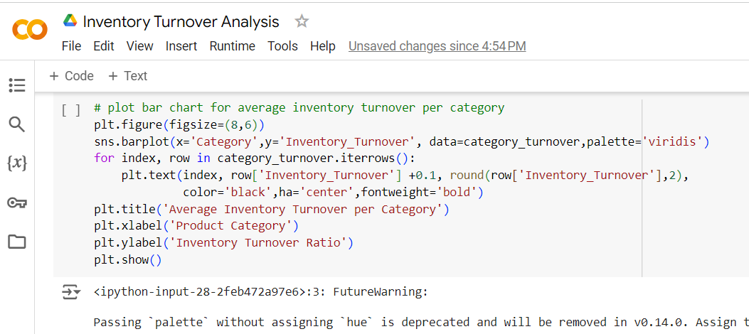

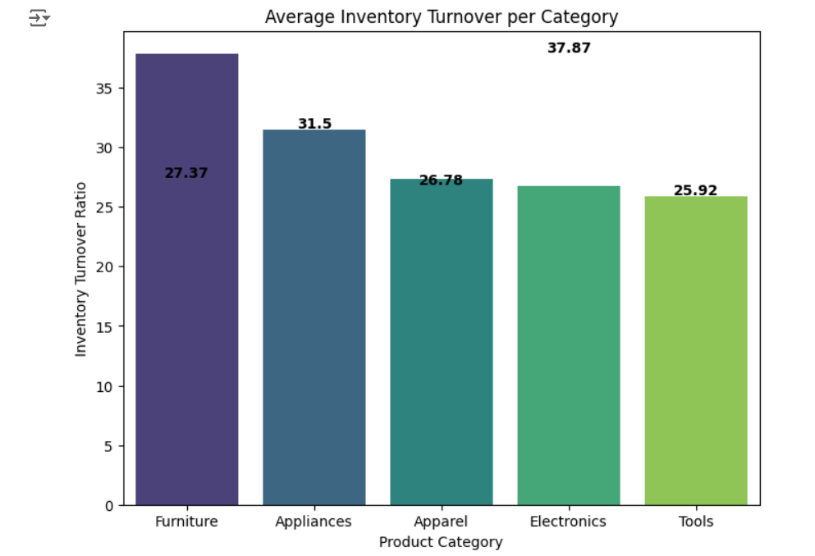

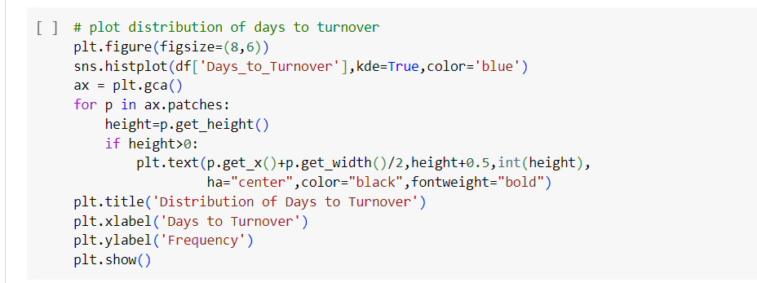

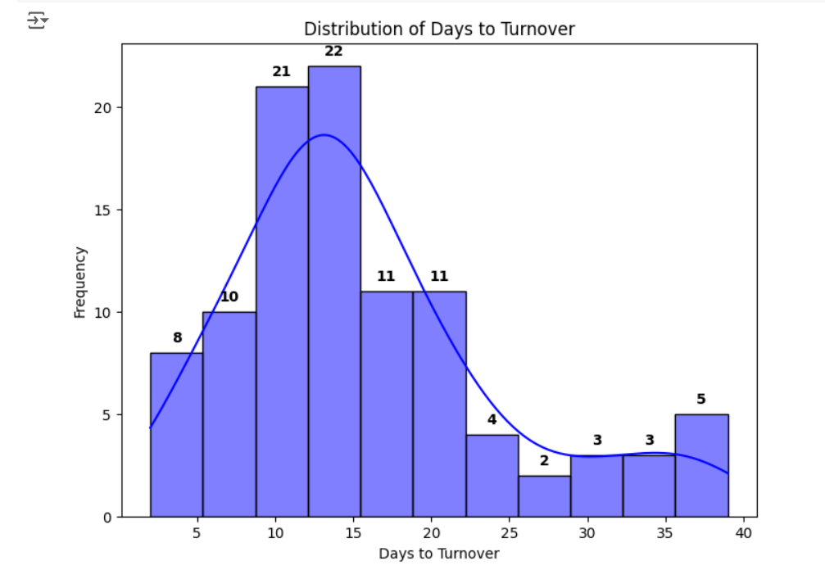

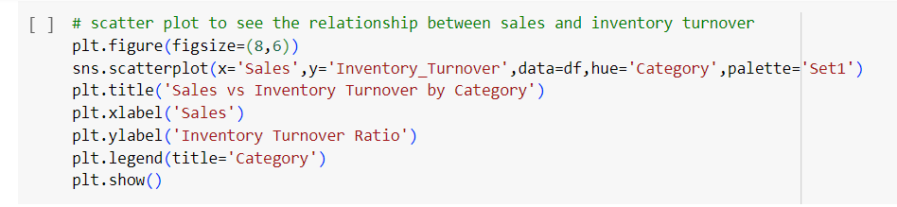

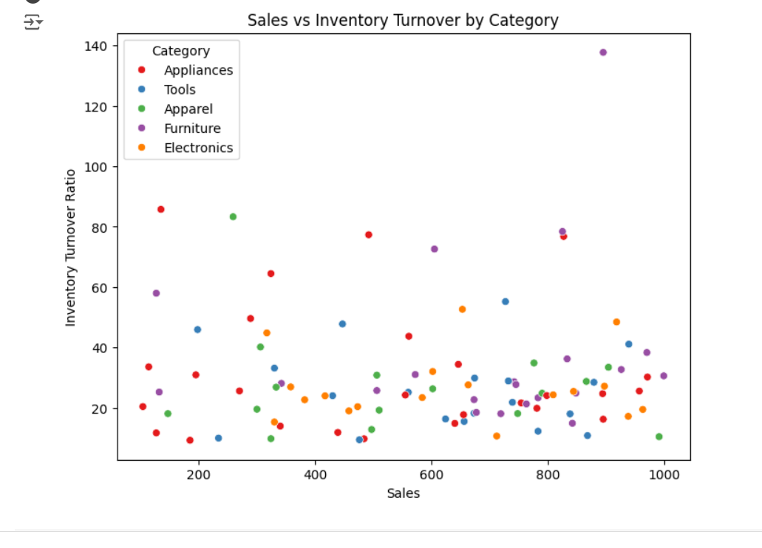

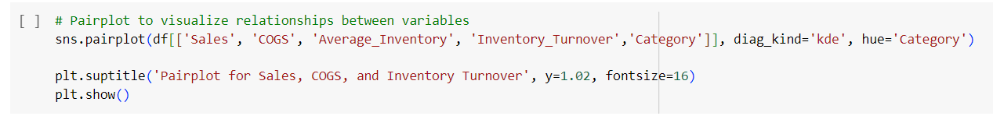

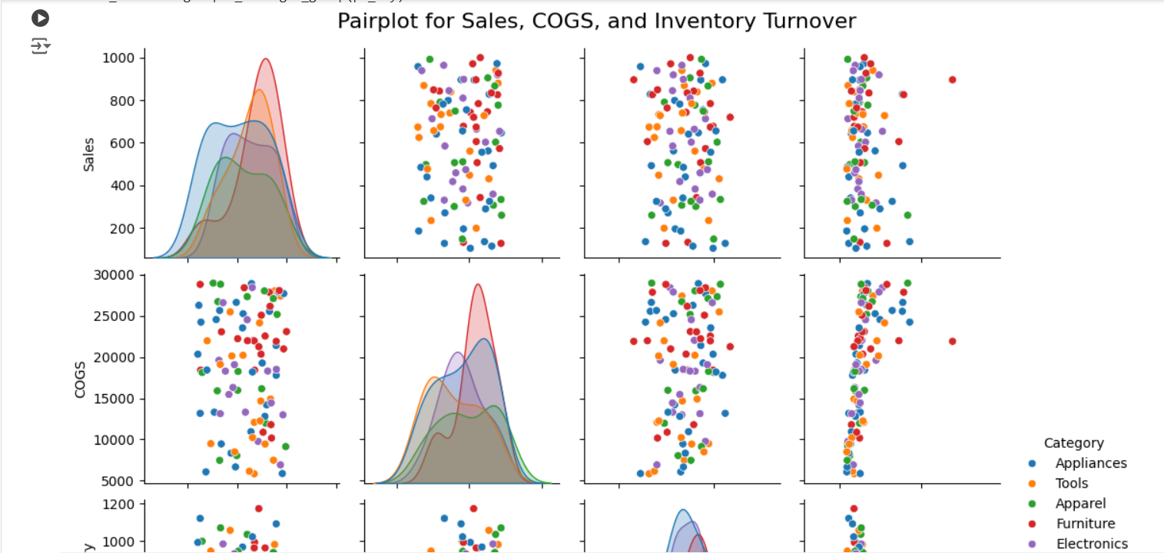

**Progress**

* **Accomplishments:**

1. Improved understanding of product categories with the highest and lowest inventory turnover.
2. Enhanced decision-making by identifying slow-moving and fast-moving inventory items.
3. Optimized inventory management strategies by analyzing days to turnover for each product category.
4. Provided data-driven insights for reducing excess inventory and minimizing carrying costs.
5. Supported continuous monitoring of inventory performance through calculated turnover ratios and days to turnover.

* **Metrics:**

1. Inventory Turnover Ratio: Measures how efficiently inventory is being used (calculated as COGS / Average Inventory).
2. Average Inventory: Calculated as the average of beginning and ending inventory for each item.
3. Days to Turnover: Indicates the average number of days it takes to sell the inventory (365 / Inventory Turnover).
4. Sales: Total sales value for each item, providing context for turnover performance.
5. COGS (Cost of Goods Sold): Used to calculate inventory turnover, indicating direct costs associated with production.

**Challenges and Solutions**

* **Challenges Faced:**

1. Ensuring the accuracy of inventory, sales, and COGS data for reliable turnover calculations.
2. Difficulty in summarizing inventory turnover for multiple product categories efficiently.
3. Managing the complexity of varying inventory levels across different categories.
4. Difficulty in pinpointing products with low turnover that negatively impact inventory efficiency.

* **Solutions Implemented:**

1. Implement data validation techniques to ensure the accuracy of sales, inventory, and COGS data before analysis.
2. Use Python's NumPy and Pandas to automate average inventory and turnover ratio calculations, streamlining data aggregation.
3. Group data by category to identify specific trends in inventory turnover, enabling more focused insights.
4. Apply visualizations like bar charts to clearly identify low turnover items, facilitating faster decision-making.

**Next Steps**

* **Upcoming Tasks:** Prioritize tasks, ensure data accuracy, optimize code for efficiency, and focus on clear visualizations.
* **Goals:** Refine accuracy for better decision-making, implement real-time monitoring to boost responsiveness.

**Conclusion**

* **Summary:** Inventory turnover analysis in the manufacturing sector is crucial for optimizing inventory management and enhancing operational efficiency. By calculating turnover ratios and days to turnover, organizations can identify slow-moving products and streamline inventory levels. Implementing data-driven insights leads to cost reductions and improved decision-making. Overall, effective inventory turnover analysis supports sustainable growth and profitability in the manufacturing industry.
* **Acknowledgments:** Thank you all for your attention and engagement, I appreciate your interest in the Inventory Turnover Analysis in Manufacturing sector.